**DATAWARE HOUSING AND DATA MINING**

**Quiz No:4**

Name: Muhammad Bilal Ahmed

Roll No: FA20-BCS-041

|  |  |
| --- | --- |
| **Through Process** | **Query Sequence** |
| What is special about last quarter? | What were quarterly sale during year 2016? |
| Profit increases by large amount consistently during last year? | What were quarterly sale at Product level? |
| An enterprise-wide increase in profit | What were monthly sale of Products Group by Employees? |

**Answers**

We can answer these questions from power bi using slicers, visuals like card, graph or pie chart.

**Question 1**

**What were quarterly sale during year 2016?**

**Answer:**

In slicer year 2016 is selected

**Question 2**

**What were quarterly sale at Product level?**

**Answer:**

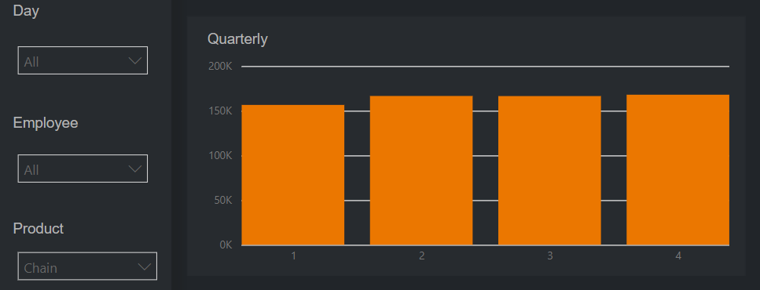

**Question 3**

**What were monthly sale of Products Group by Employees?**

**Answer:**

